Brothertown Indian Nation Request for Photo Identification Card
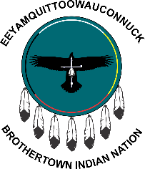
Brothertown Indian Nation
PO Box 2206, Fond du Lac, WI 54936-2206
Phone: 920-929-9964
ATTN: Enrollment Committee

Check one of the following:
- Identification Card for Tribal Members 18-64 years (valid for 4 years) $25.00
- Identification Card for Tribal Members 65 years+ (valid for 4 years) $20.00
- Identification Card for Tribal Members under 18 years (valid for 4 years) $20.00
- Replacement Card for Loss or Stolen card $15.00
Please include a high quality photo of the applicant only with a straight, front face shot and a solid light blue colored background. No hats or sunglasses. Please allow 4-6 weeks for delivery. PLEASE USE BLACK INK.
PLEASE SEND A 4X6 PICTURE WITH A SOLID BACKGROUND

Name:
First Middle (Maiden) Last

Date of Birth
Enrollment Number
Gender/Sex

Address

City
State
Zip

Descendent (1839 or 1901 Roll)
Telephone or Mobile

Hair Color
Eye Color
Height
Weight

Applicant Signature or Legal Guardian (not to be signed by minors)
Date

**PLEASE sign on back of page with a Sharpie Fine Point Permanent Marker for signature to show on ID card**

For your benefit, PLEASE always notify the Nation of any address, phone, or name changes.

Enrollment Committee Section ONLY

I hereby certify that _________________________________________________________________________________ is an enrolled member of the Brothertown Indian Nation, according to the available records of the Nation.

Enrollment Committee Official
Date

