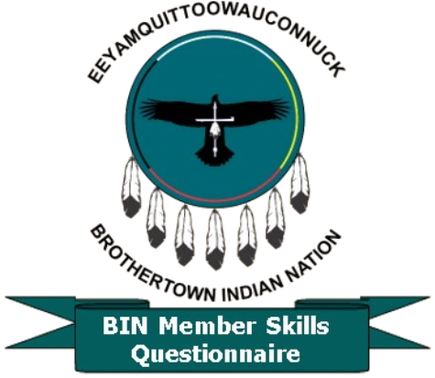**Brothertown Indian Nation**

Member skills, experience, talents, knowledge, and passion

Questionnaire

(under development)

Basic information

Name

First: __________ Last: _______________

Email: _______________________

Phone not mandatory, but helpful: ________________

***The following questions are neither a qualifier nor a disqualifier and are confidential*** *– used only to help us get to know you better, understand who you are, and how you are connected to the tribe*.

City and State where you reside: ___________________*

*We anticipate that many of the respondents will not be local to Fond du Lac; this is not a bad thing, as we have many things going on, and location is not an issue. However, we encourage any member to try to make it to Wisconsin if possible – we know that travel can be difficult and costly – but there is a place for you to help, and you are welcome.*

Finally: Friend of the tribe? Family of a Tribal member? Non-enrolled member, or Enrolled member?

Ancestors _________ and if known, your tribal enrollment No.: __________

***The intent of this survey***

* *To identify our members' skills, strengths, knowledge, passions, and interests.*
* *This is not to be nosy, but we know that our Brothertown Family has extraordinary talents, which are mostly unknown to the Tribe.*
* The Tribe needs talent in so many areas, and we do not know our members that well (sad but true). The Talents we know about, as I said, came only through a conversation that, before that, we had no clue about.

**As we move forward, our tribal family needs to come together for Restoration, and we require the engagement and assistance of all our members to succeed. No financial pressure, no location limitations, just that you are a member (enrolled or other), or a Family or Friend of the tribe.**

Talent can be just about anything. Below is a list of ideas to give you an idea (although this is only a brief list – your abilities may not be listed), but they are needed.

Some Areas:

Writing Skills: (be it newspaper, author, or Grant writing) – using the written word is your talent.

Your skill: ______________________________________________________________

______________________________________________________________________

Technical Skills: computer, internet, webpage, blogs, or even programming. Marketing, Media, Facebook, Instagram, etc.

Your skill: ______________________________________________________________

______________________________________________________________________

Any specific jobs you’ve held that relate to or touch Indigenous peoples or the government?

_______________________________________________

Artistic or Graphic ability/experience or crafting skills, etc.

Skills or experience: _____________________________________________________

______________________________________________________________________

Political skills, experience, jobs, or connections? These will be and are helpful during our Restoration process.

______________________________________________________________________

______________________________________________________________________

Experience, or skills in History, research, Archeology, or other related experience.

______________________________________________________________________

______________________________________________________________________

Etc.… work in progress….